56. Design and analysis of disk brake caliper

Abstract
Safety aspect in automotive engineering is of prime importance. Effective Braking system along with good suspension systems, good handling and safe cornering is very important for determining the performance of the vehicle
A disc brake is a wheel brake that slows rotation of the wheel by the friction caused by pushing brake pads against a brake disc with a set of calipers.
In this project we design the model of disk brake caliper by using solid works premium 2016 and static structural analysis is carried out in solid works simulation tool by different materials and will find out on given working pressure load which material can sustain best for stress ,strain and deformation.
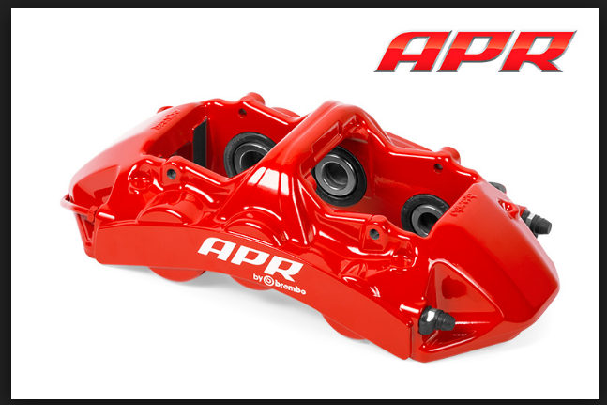
Figure.1 Brake caliper

